Christian Fundamentalism and Creation
What do Fundamental Christians believe about creation?

Introduction: How did the world begin?
Throughout history, different cultures and belief systems have developed explanations for how the world came to exist. Some believe in the Big Bang (a scientific explanation involving a massive expansion 13.8 billion years ago) , while others follow religious accounts like the Dreaming (Aboriginal Australian) or the Cosmic Egg (Hindu traditions).
Task 1: Reflection
- How do you think the world came to exist?
- What is your reasoning for this view?
________________________________________________________________________________________________________________________________________________________________________________________________________________________________________________________________________________________________________________________________________________________________________________________________________________________________________________________________________________________________________________________________________________

Part 1: Understanding Three Ways to Read the Bible
Not all Christians read the Bible in the same way. Their interpretation often falls into one of three categories: Fundamentalist, Conservative, or Liberal.
Interpretation Style | Core Beliefs
Fundamentalist (Literal) | Believe the Bible is the direct word of God and is completely true. It must be understood exactly as written, not as a symbol.
Conservative | Believe the Bible is inspired by God. While most of it is historically true, some parts might be symbolic or poetic. They may accept scientific ideas alongside the Bible.
Liberal | Believe the Bible is a collection of human writings about God. Many stories are seen as metaphors or symbols. The spiritual message is more important than literal facts.

Task 2: Check Your Understanding
- Which group believes the Bible is the "direct word of God"? ____________________
- Which group is most likely to accept scientific theories like the Big Bang? ____________________
- How would a Liberal Christian view a story like Noah's Ark? (Circle one): A fact / A symbol

Part 2: The Creation Account (Genesis 1)
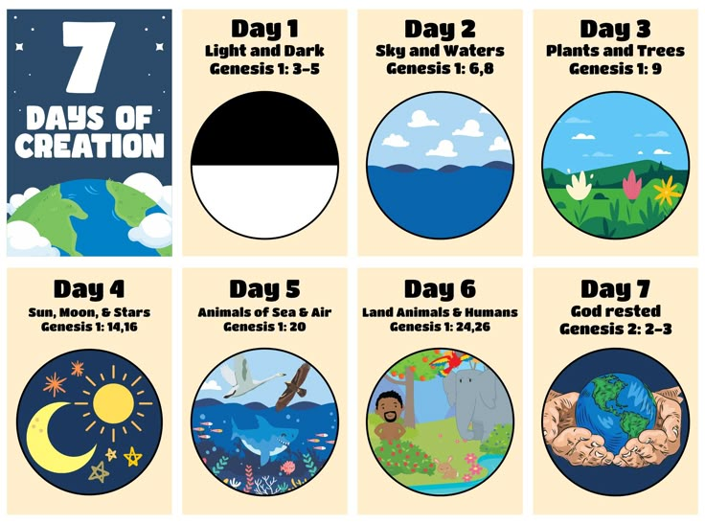
In the first book of the Bible, called Genesis, there is an account of how God created the world.
- The Process: God creates the world in six days and rests on the seventh.
- Humanity: Humans are made in God’s image (Imago Dei) and given the responsibility to care for the Earth.
- The Message: For Christians, this account shows that God is the ultimate creator behind the universe.
Task 3: Sequence of Creation
Based on the text above, answer the following:
- How many days did it take God to create the world? ______________
- What makes humans different from the rest of creation according to this account?
________________________________________________________________________________________________________________________________________________________________________________

Part 3: The Fundamentalist View of Creation
Because Fundamentalists have a literal understanding of the Bible, they view the Genesis account very specifically.
- Literal History: They believe Genesis 1 is a historically accurate description of exactly what happened.
- Actual Days: They believe God created everything in six actual 24-hour days.
- Rejection of Evolution: Because they take the Bible literally, many Fundamentalists reject scientific theories (like evolution) that suggest humans developed over millions of years.
Task 4: Comparison Task Read the two statements below and identify which represents a Fundamentalist view and which represents a Liberal view.
- Statement A: "Genesis 1 is a beautiful poem. It isn't a science book; it just teaches us that God is the source of all life."
  - View: __________________________
- Statement B: "The world was made in exactly six days. If the Bible says it happened that way, then it is a historical fact."
  - View: __________________________

Part 4: Final Review
Task 5: Short Answer Summary
- Why don't all Christians agree on how the world was created? (Think about how they read the Bible)
______________________________________________________________________________________________________________________________________________________________________________________________________________________________________________________
- What does the term "Fundamentalist" mean in a Christian context?
________________________________________________________________________________________________________________________________________________________________________________________________________________________________________________________________________________________________________________________________________

